MINISTRY OF HIGHER EDUCATION

HIGHER INSTITUTE OF PETROLEUM & LOGISTICS (HIPAL)
MINISTERE DE L’ENSEIGNEMENT SUPERIEUR

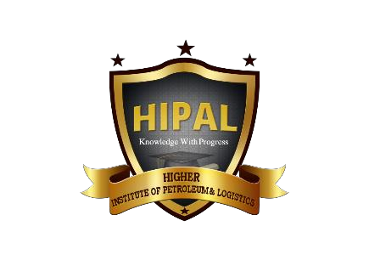
HIGHER INSTITUTE OF PETROLEUM & LOGISTICS (HIPAL)

DECISION NO 20-00412/MINESUP
P.O.BOX 446 MANKON, BAMENDA, CAMEROON - TEL: 670 191 902/ 672 140 376
INFO@HIPAL.EDU.CM
WEB:WWW.HIPA.L.EDU.CM

01/09/2023
INDUSTRIAL EXPERIENCE EVALUATION FORM
NAME OF STUDENT: ______________________________________________________
SPECIALITY: ___________________________________ LEVEL ___________________
NAME OF ENTERPRISE / COMPANY: ________________________________________
NAME OF INTERNSHIP SUPERVISOR: _______________________________________
POSITION OF INTERNSHIP SUPERVISOR: ___________________________________

NO | EVALUATION GUIDE | MARKS
1. | Assiduity (Seriousness) | /4
2. | Professional Aptitude | /8
3. | Spirit of Initiative | /2
4. | Ability to Produce | /2
5. | Ability to Organize | /2
6. | Team Spirit | /2
TOTAL /20
Comments:________________________________________________________________________________________________________________________________________________________________________________________________________________________________
Done at: ______________________________ on the: ______________________________
INTERNSHIP SUPERVISOR
(Name and Stamp)
This form should be forwarded in a seal envelop to HIPAL at the end of the internship

